

**Ahsanullah University of Science & Technology**

**Department of Computer Science & Engineering**

**Project Report on**

**AmariShop Management System**

**Course Title: Database Lab**

**Course No: CSE 3104**

**Submitted to-**

**Mr. Nazmus Sakib**

Assistant Professor

AUST

**Mr. Munshi Rejwan Ala Muid**

Lecturer

AUST

**Prepared By-**

**Group Members-**

1. Name: Fahim Rahman

ID : 18.02.04.028

**Date of Submission: October 04, 2021**

**Abstract**

A shop management system is an essential tool for maximizing your effectiveness and making your auto repair business run smoothly. The right shop management software can help you improve your internal communication, save you time, and help you understand which areas are performing efficiently or may need attention, so you can make important business decisions that lead to improved productivity and profitability. AmariShop management system brings the flexibility to run the business effectively. This project is more focused on database management. Joint Operations are performed to establish relationships on tables instead of Cartesian Product as some tables may contain a large data set with more than 5/6 columns. Aggregate functions are used to summarize the table’s column.

In this project, Java language is used along with an open-source Java-based framework, JavaFX, and the concept of OOP Programming has been followed. A relational database management system (RDBMS), Microsoft SQL Server, is used as a database server.

**Objective**

Our goal is to analyze the project scenario and find out the possible entities, relationships, and attributes. Then we will make a Relational Schema, afterward prepare an ER Diagram according to Relational Schema. We will ensure that the cardinality constraints and the relationships are accurate and meet up real-life scenarios. We will make the UI user-friendly so that users can easily find out the features they need and save time. We will bring out the most output of JavaFX. Finally, we will solve the business management-related problems and would like to help the businesses grow up quickly as well as our country to establish a positive economic growth.

**Project Scenario**

According to AmariShop owners, AmariShop is a super shop located in Tejgaon, Dhaka. Here different types of products are sold in different categories. They have some dedicated customers and offer discounts to engage more customers. The price of the product doesn’t include vat considering that vat percentage may vary from product to product. They buy products from manufacturers or wholesalers and sell them.

The product types are Electronic Devices, Electronic Accessories, TV & Home Appliances, Health & Beauty, Baby products & Toys, Home & Lifestyle, Women’s Fashion, Men’s Fashion, Watches & Accessories, and Sports.

The number/amount of products may vary from time to time. When products become unavailable and they try to connect with the wholesalers.

There are some salespeople attendants, one operator, one cashier, and one security guard giving their service. For security purposes, they need to store their information. One’s monthly salary can be cut if he/she becomes absent in one day. They offer bonuses at Eid festivals to them.

The management of the workers and the products are getting difficult day by day as our business is growing. Therefore a management system would be very helpful. They have a plan to expand our business to an online e-commerce shop in the future.

**Analysing Project Scenario**

|  |  |  |
| --- | --- | --- |
| **Possible Entity** | **Possible Relationship** | **Possible Attributes** |
| 1. Shop  2. Employee [Salespeople, 1 operator, 1 cashier, 1 security guard]  3. Customer  4. Product | Customer **buy** Products  Shop **has** Employees | 1. Employee  Employee_id  Employee_name  Employee_email  Employee_phone  Employee_salary  Employee_bonus  2. Customer  Customer_id  Customer_name  Customer_email  3. Product  Product_id  Product_price  Product_discount  Product_unit [kg/liter/unit]  Product_category  Product_available[Bool]  4. Shop  shopID  Shop_name  Shop_owner  Shop_address  Shop_contact  Shop_costing  Shop_profit |

**ER Diagram**

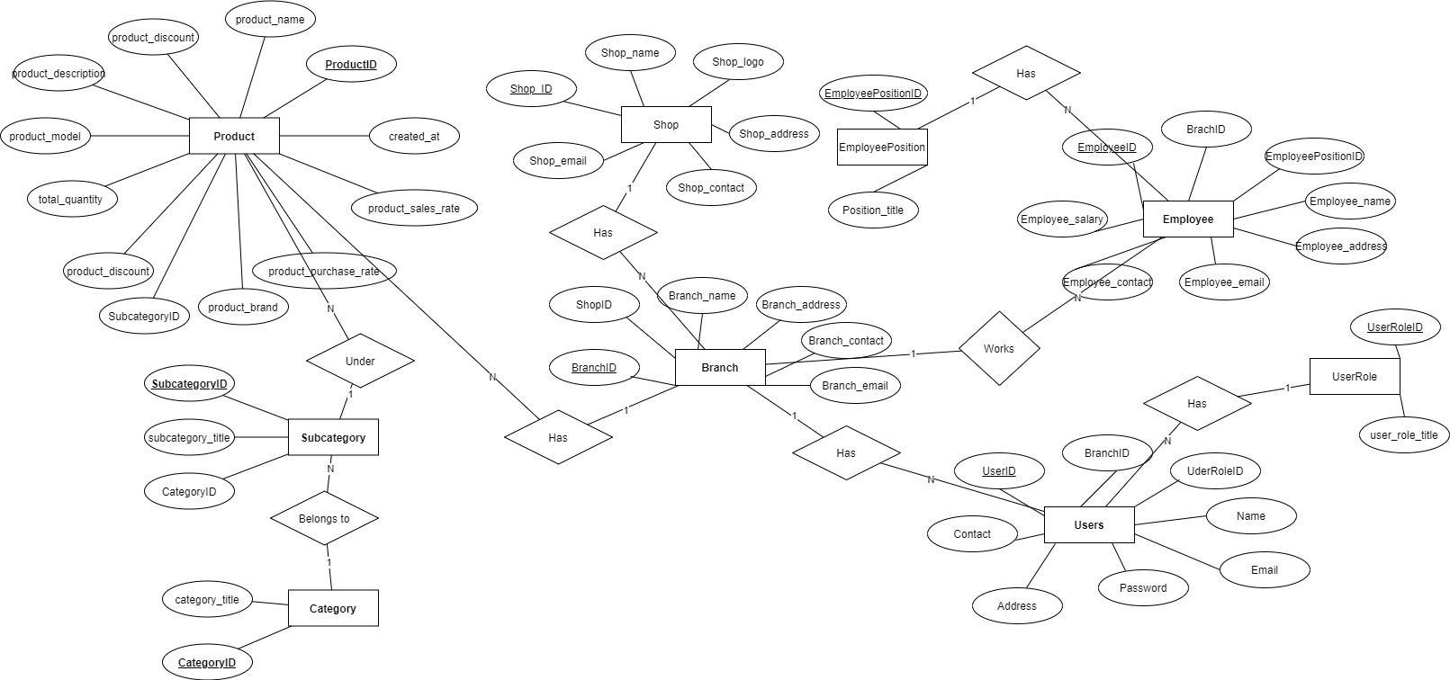

**Relational Schema**

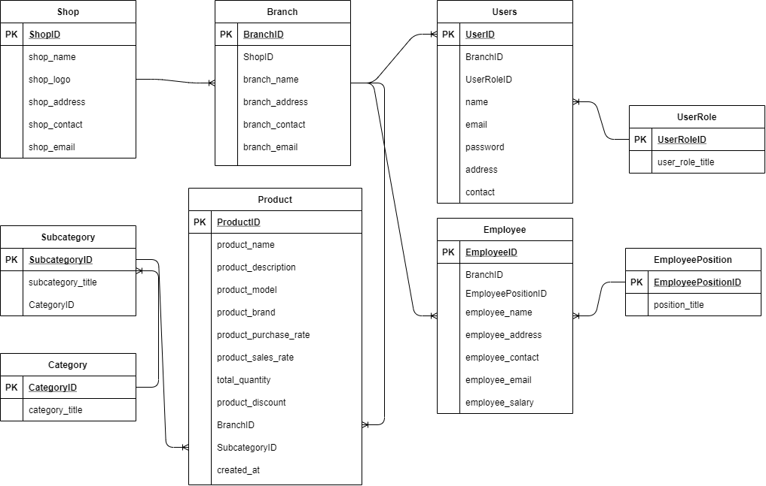

**Key Features**

* User-Friendly Interface & Easy to use
* Excellent UI design
* Your security is our main priority
* Faster & Efficient Database Management with Microsoft SQL Server

**Strategy & Technology Used**

We will rely on Microsoft SQL Server which is budget-friendly therefore we focus on faster and efficient database management. This project is on JavaFX which is an open-source Java-based framework for developing rich client applications.

**Findings**

**Calculations:**

Total Profit = GSUM((product_sales_rate - product_purchase_rate - product_discount) $×$ total_quantity) $σ month(created_at) = month(getdate()) ∧ year(created_at) = year(getdate())$ (Product)

Average Profit = GAVERAGE((product_sales_rate - product_purchase_rate - product_discount) $×$ total_quantity) $σ month(created_at) = month(getdate()) ∧ year(created_at) = year(getdate())$ (Product)

Maximum Purchase= GMAX((product_sales_rate - product_purchase_rate - product_discount) $×$ total_quantity) $σ month(created_at) = month(getdate()) ∧ year(created_at) = year(getdate())$ (Product)

Total Purchase = GSUM(product_purchase_rate $×$ total_quantity) $σ month(created_at) = month(getdate()) ∧ year(created_at) = year(getdate())$ (Product)

**Implementations:**

select sum((product_sales_rate-product_purchase_rate-product_discount)*total_quantity) as total_profit,

avg((product_sales_rate-product_purchase_rate-product_discount)*total_quantity) as avg_profit,

max(product_purchase_rate*total_quantity) as max_purchase,

sum(product_purchase_rate*total_quantity) as total_purchase from Product

where month(created_at) = month(getdate()) and year(created_at) = year(getdate())

SQL files containing all queries related to this project are attached to this submission.

**Recommendations & Future Plan**

We will introduce a sales feature where products can be sold directly from the admin panel and dedicated customers can be added for extra discounts. The software update will meet up with a new feature to track employee attendance.

**Conclusion**

This project comes with many challenges and we have gained practical experience in database management, different kinds of database queries by this project. This was a great opportunity to be familiar with the Java programming language & JavaFX framework.